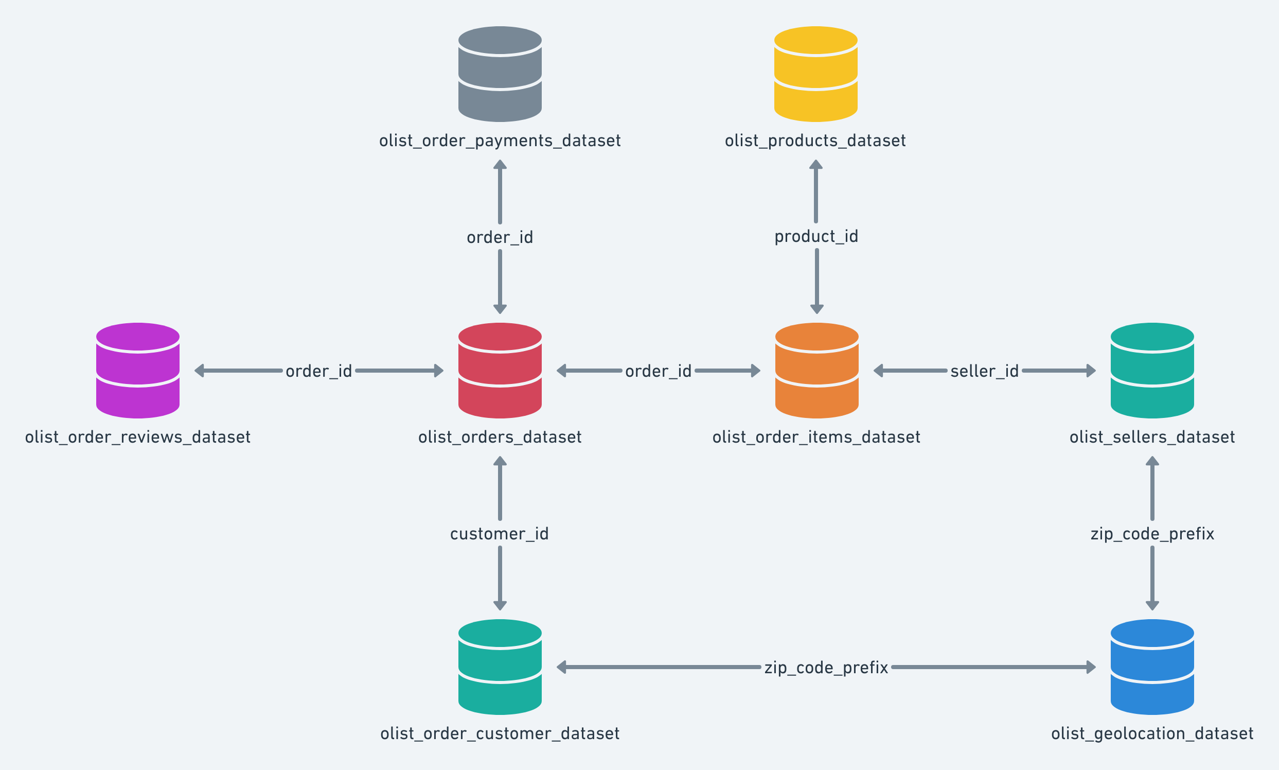

* Order id
* Customer id
* Order status
* Invoiced
* Shipped
* Delivered
* Unavailable
* Purchas timestamp
* Approval timestamp
* Delivered courier
* Delivered customer
* Estimated delivery
* Review id
* Order id
* Score
* Comment title
* Comment message
* Creation date
* Answer timestamp
* Order id
* Sequential
* Type
* Installment
* Value
* Customer id
* Unique id
* Zip code
* City
* State
* Id
* Zip code
* City
* State
* Zip code
* Latitude
* Longitude
* City
* State
* Order id
* Item id
* Product id
* Seller id
* Price
* Freight
* Product id
* Category
* Name length
* Description length
* Photo quantity
* Weight
* Length
* Height width